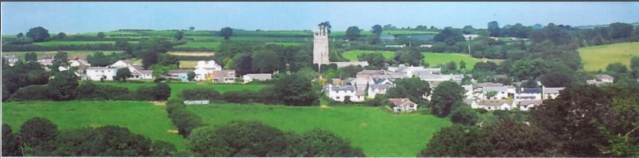
28th January 2026
Dear Councillor,
You are summoned to attend a meeting of North Hill Parish Council on Monday 2nd February 2026 at 7.30pm in the Village Hall.
Please find attached the agenda for our meeting. We ask that if any member of the public has issues, they would like to raise that they contact the clerk prior to the meeting so that we can best manage them.
Please remember that the time allotted for Matters of Community Concern is not a forum to discuss what has taken place during this meeting and that any matter raised here would likely be added to the NEXT meeting agenda for discussion.
Yours faithfully,
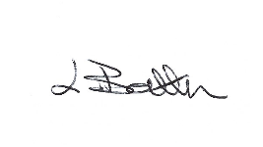
Lena Batten, Clerk to the Council
Members of the public are welcome to attend the meeting. However, we would like those attending to register prior to the meeting by emailing the Parish Clerk. Email: clerk@northhillparish.org.uk
AGENDA
- TO RECEIVE APOLOGIES:
- CODE OF CONDUCT : a) TO RECEIVE DECLARATIONS b) TO GRANT DISPENSATIONS:
3. PUBLIC COMMENTS ON ITEMS ON THE AGENDA ONLY:
4. TO RECEIVE AND APPROVE THE MINUTES OF THE 5th JANUARY 2026 FULL COUNCIL MEETING:
5. ANY MATTERS ARISING FROM PAST MINUTES NOT ON THE CURRENT AGENDA:
6. TO CONSIDER PLANNING APPLICATIONS RECEIVED FROM CORNWALL COUNCIL BY DATE OF THIS MEETING:
6.1 PA25/09647 – Unit 1, Moorview, Coads Green, PL15 7LY – Change of use Class E to use Class C3 (residential dwelling house) with various external alterations and additions.
7. ANY APPLICATIONS RECEIVED BEFORE THE DATE OF THIS MEETING: None.
8. TO REVIEW CORRESPONDENCE AND TO AGREED RESPONSES REQUIRED:
8.1 To note for information a CHIP expression has been submitted for 30mph speed signs at Bathpool.
8.2 To consider / resolve purchase of any trees from Arbor Farm who work with The Forest for Cornwall.
8.3 To note for information the clerk has completed a re-declaration of compliance with The Pensions
Regulator as requested for a further three years.
8.4 To consider / resolve the CIL find 2026 is now open for applications with any expressions of interest
required before the 27th February.
8.5 To consider / resolve a request from one member of The Sunflowers and Choughs Club to fly the
Ukrainian flag on the 24th February 2026.
9. TO REVIEW DETAILS FOR NORTH HILL PARISH COUNCIL CEMETERY:
9.1 To consider / resolve agreement for the tender advert, dates and initial job specifications for the
cemetery path works.
10. APPROVAL OF THE LIST OF PAYMENTS / RECEIPTS FOR JANUARY 2026 & TO RECEIVE JANUARY 2026 BANK STATEMENT:
10.1 AUTHORISATION OF EXPENSES INCLUDING SALARY:
i) £18.00 (PAYE G. Pollard payroll, dd)
ii) £702.92 (Lena Batten, Salary Jan)
iii) £43.64 (room rent)
iv) £150.07 (Lena Batten, N.I. and tax Jan)
v) £45.00 (North Hill Village Hall room hire)
vi) £43.20 (upgrade of email accounts for Cllrs)
vii) £20.00 (Lena Batten, purchase of M&S voucher for defib hosts)
viii) £58.19 (Viking, ink)
10.2 RECEIPTS:
i) £388.84 (VAT reimbursement)
10..3 To receive January 2026 bank statement:
Bank Statement as of 22nd January 2026 £16,456.94
11. TO REVIEW MONTHLY BUDGET RECONCILIATIONS:
11.1 Budget Sheet Attached.
12. TO REVIEW MONTHLY RAG: (Red, Amber, Green)
12.1 RAG Sheet attached.
13. REPORT FROM CORNWALL COUNCIL WARD MEMBER COUNCILLOR PARSONS:
14. ITEMS FOR INCLUSION AT THE NEXT MEETING:
15. DATE & TIME OF NEXT MEETING:
16. CLOSE OF BUSINESS:

